Ten Prophetic Clues Concerning
Simeon – the Scots

There is not much direct history connecting the tribe of Simeon to the Scottish people. Even the Caucasian population of Scotland comes from various backgrounds. One can compare this to Jewry. The Jewish people have known many proselytes, yet, there has been a core of the tribe of Judah (and some of Levi & Benjamin) over the past 2500 years. The core passes on characteristics and genes to the periphery. Looking at the ‘prophetic clues’, one has to conclude, that a core of the tribe of Simeon once found its way to Scotland. This core passed its characteristics and genes onto the influx of others. The more fulfilled prophetic clues we find, the stronger our case. What follows is not historic proof, but proof by revelation.

1st Clue: Simeon: scattered

SIMEON AND LEVI ARE BROTHERS; weapons of violence are their swords. 6 O my soul, come not into their council; O my spirit, be not joined to their company; for in their anger they slay men, and in their wantonness they hamstring oxen. 7 Cursed be their anger, for it is fierce; and their wrath, for it is cruel! I WILL DIVIDE THEM IN JACOB AND SCATTER THEM IN ISRAEL (Genesis 49:5-7, RSV throughout unless mentioned otherwise).

The Simeonites were more or less scattered in the territory of Judah. After king David we no longer hear of them. Only two tribes are counted for the southern Kingdom of Judah: Judah and Benjamin.

Scottish diaspora according to Wikipedia:

The Scots are dispersed over the Anglo-Saxon world. And it is not just Nova Scotia (New Scotland) where they ended up:
Wikipedia: “The Scottish diaspora consists of Scottish people who emigrated from Scotland and their descendants. The diaspora is concentrated in countries such as the United States, Canada, Australia, England, New Zealand, Ireland and to a lesser extent Argentina, Chile, and Brazil. The Scottish diaspora has been estimated by the Scottish Government to be between 28 and 40 million people worldwide. Other estimates have ranged as high as 80 million.”
Scotland 4,446,000 (2011)
(Scottish descent only.)^{[2]}
United States^{B} | 5,393,554 – 6,006,955^{[3][4]}
Canada^{C} | 4,719,850^{[5]}
Australia^{H} | 1,792,600^{[6]}
England^{D} | 795,000
Argentina | 100,000
Chile | 80,000
France | 45,000
Poland | 15,000
New Zealand^{F} | 12,792^{[7]}
South Africa^{F} | 11,160
Isle of Man | 2,403^{[8]}

2nd Clue: Simeon: violence

On the third day, when they were sore, two of the sons of Jacob, SIMEON AND LEVI, Dinah's brothers, TOOK THEIR SWORDS AND CAME UPON THE CITY UNAWARES, AND KILLED ALL THE MALES. THEY SLEW HAMOR AND HIS SON SHECHEM WITH THE SWORD, and took Dinah out of Shechem's house, and went away (Gen 34:25-26).
Simeon and Levi are brothers; WEAPONS OF VIOLENCE ARE THEIR SWORDS. 6 O my soul, come not into their council; O my spirit, be not joined to their company; FOR IN THEIR ANGER THEY SLAY MEN, AND IN THEIR WANTONNESS THEY HAMSTRING OXEN. 7 CURSED BE THEIR ANGER, FOR IT IS FIERCE; AND THEIR WRATH, FOR IT IS CRUEL! I will divide them in Jacob and scatter them in Israel (Gen 49:5-7).
[Simeon]: I became strong exceedingly; I shrank from no deed, NOR WAS I AFRAID OF ANYTHING. FOR MY HEART WAS HARD, AND MY MIND WAS UNMOVEABLE, AND MY BOWELS UNFEELING: because VALOUR also has been given from the Most High to men in soul and in body. And at that time I was jealous of Joseph because our father loved him; AND I SET MY MIND AGAINST HIM TO DESTROY HIM ... Judah our brother sold him to the Ishmaelites. And when Reuben came he was grieved, for he wished to have restored him safe to his father. BUT I WAS ANGRY AGAINST JUDAH IN THAT HE LET HIM GO AWAY ALIVE ... (Testament of Simeon).

Scotland

Every country has its own violent past, but Scottish history seems to be slightly more violent. This started with the brave, violent, wild tribes of Picts and Scots in the time of the Romans. Rome failed to subdue them. So Rome built Hadrian's Wall in Northern England to keep them out of the Roman Empire.
The English conquered Wales and Ireland, but they failed to do so with Scotland (Bannockburn). The Scots remained independent. Unity with England was only achieved when James VI of Scotland, as James I of England, succeeded the childless Elisabeth I. The personal union of 1603 became the UK in 1706.

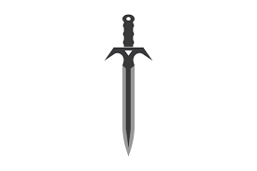

Clan Violence

The Scotsman: “While the clan system offered kinship, identity, food and livelihood it also created a ready supply of men willing to fight for their chief. Here we look at six of the bloodiest battles of Scotland’s ancient past where clansmen were pitted against their rivals, the establishment - and even their own father - as they entered brutal survival mode.”
https://www.scotsman.com/whats-on/arts-and-entertainment/6-of-scotlands-bloodiest-clan-battles-594844
Scottish regiments after 1745 (Culloden):

Wikipedia: “Traditionally, Scottish regiments cultivate a reputation of exceptional fierceness in combat and are often given romantic portrayals in popular media. Within Scotland itself, regiments of the Scottish Lowlands did not adopt as distinctively "Scottish" (specifically Scottish Highland) uniforms until the late Victorian Era and even then the kilt, that most distinctive aspect of the Highland soldier, was not adopted wholesale.”

Scotland has a bleak and embarrassing history with violence

“In 2005, a United Nations report named Scotland as the most violent country in the developed world. You were 3x more likely to be a victim of assault in Glasgow than you were in America. Glasgow was dubbed the “Murder Capital of Europe” with a murder rate higher than Romania and Albania. Scotland’s rate of Deaths by Violence was almost double that of our neighbouring countries in the United Kingdom.”
https://www.mav.scot/topic/scotlands-shameful-history-with-violence/

3rd Clue: Simeon: pride & honour

Now Dinah the daughter of Leah, whom she had borne to Jacob, went out to visit the women of the land; 2 and when Shechem the son of Hamor the Hivite, the prince of the land, saw her, HE SEIZED HER AND LAY WITH HER AND HUMBLED [raped] HER. 3 And his soul was drawn to Dinah the daughter of Jacob; he loved the maiden and spoke tenderly to her. 4 So Shechem spoke to his father Hamor, saying, "Get me this maiden for my wife." 5 Now Jacob heard THAT HE HAD DEFILED HIS DAUGHTER DINAH; but his sons were with his cattle in the field, so Jacob held his peace until they came. 6 And Hamor the father of Shechem went out to Jacob to speak with him. 7 The sons of Jacob came in from the field when they heard of it; AND THE MEN WERE INDIGNANT AND VERY ANGRY, BECAUSE HE HAD WROUGHT FOLLY IN ISRAEL BY LYING WITH JACOB'S DAUGHTER, FOR SUCH A THING OUGHT NOT TO BE DONE ... 13 The sons of Jacob answered Shechem and his father Hamor deceitfully, BECAUSE HE HAD DEFILED THEIR SISTER DINAH. 14 They said to them, "We cannot do this thing, to give our sister to one who is uncircumcised, for that would be a disgrace to us ... 30 Then Jacob said to SIMEON AND LEVI, "You have brought trouble on me by making me odious to the inhabitants of the land, the Canaanites and the Per'izzites; my numbers are few, and if they gather themselves against me and attack me, I shall be destroyed, both I and my household." 31 But they said, "SHOULD HE TREAT OUR SISTER AS A HARLOT?" (Gen 34).

Pride, honour & revenge

Shechem ben Hamor seduced and raped Dinah the daughter of Jacob. This was dishounor, and in their pride Simeon and Levi sought revenge. The death of Shechem was not enough. In their desire for revenge, the entire city of Shechem had to be massacred.

Clan feuds

There have been many feuds between the Scottish clans. Many clan feuds were also about pride, honor and revenge. The members were very proud of their clan and their regalia, such as the kilt, the bagpipes and their tartan. On Wikipedia there are 102 articles about clan battles!
https://en.wikipedia.org/wiki/Category:Scottish_clan_battles

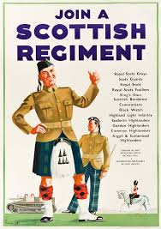

Scottish regiments

When the clans disappeared, the Scots took their decorations such as the kilt, the bagpipes and their tartan with them to the Scottish regiments, which were at the forefront of the British colonial struggle worldwide.

There is a separate Wikipedia page for Scottish regiments:
https://en.wikipedia.org/wiki/Scottish_regiment.

Dozens of regiments are listed here; existing ones, and regiments that have been disbanded. Not only British regiments, but there were or are also Scottish regiments in Canada, South Africa, USA and New Zealand.
Highland Games

Wikipedia “Highland games (Scottish Gaelic: geamannan Gàidhealach) are events held in spring and summer in Scotland and other countries with a large Scottish diaspora, as a way of celebrating Scottish and Celtic culture, especially that of the Scottish Highlands. Certain aspects of the games are so well known as to have become emblematic of Scotland, such as the bagpipes, the kilt, and the heavy events, especially the caber toss and weight over bar. While centred on competitions in piping and drumming, dancing, and Scottish heavy athletics, the games also include entertainment and exhibits related to other aspects of Scottish and Gaelic cultures.”

https://www.scotland.org/events/highland-games/about-highland-games : “Today, the games remain a stirring celebration of Scottish identity and cultural pride which have endured through centuries of political turmoil and upheaval.”

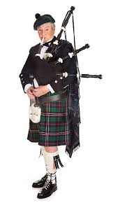

Scots are also proud that neither the Romans nor the English were able to conquer their country.

Another reason for pride are the many inventions made by Scottish people

Wikipedia “Some Scottish contributions have indirectly and directly led to controversial political ideas and policies, such as the measures taken to enforce British hegemony in the time of the British Empire. There are many books devoted solely to the subject, as well as scores of websites listing Scottish inventions and discoveries with varying degrees of science.
Even before the Industrial Revolution, Scots have been at the forefront of innovation and discovery across a wide range of spheres. Some of the most significant products of Scottish ingenuity include James Watt's steam engine, improving on that of Thomas Newcomen, the bicycle, macadamisation (not to be confused with tarmac or tarmacadam), Alexander Graham Bell's invention of the first practical telephone, John Logie Baird's invention of television, Alexander Fleming's discovery of penicillin and insulin.”
https://en.wikipedia.org/wiki/List_of_Scottish_inventions_and_discoveries

4th Clue: Simeon: mountains

AND SOME OF THEM, FIVE HUNDRED MEN OF THE SIMEONITES, WENT TO MOUNT SEIR, having as their leaders Pelati'ah, Ne-ari'ah, Rephai'ah, and Uz'ziel, the sons of Ishi; and they destroyed the remnant of the Amal'ekites that had escaped, AND THEY HAVE DWELT THERE to this day (1Chronicles 4:42-43).

Seir Mountains

Wikipedia: “Mount Seir (Hebrew: הַר-שֵׂעִיר, romanized: Har Sēʿir) is the ancient and biblical name for a mountainous region stretching between the Dead Sea and the Gulf of Aqaba in the northwestern region of Edom and southeast of the Kingdom of Judah.
Al-Sharat roughly corresponds to the biblical Mount Seir. In modern-day Jordan, the region of Al-Sharat starts immediately south of Wadi Mujib [Arnon gorge] The northern range contains mountains with peaks up to 1,200 meters above sea level, while to the south the mountains get as high as 1,500 metres (4,900 feet) above sea level.”

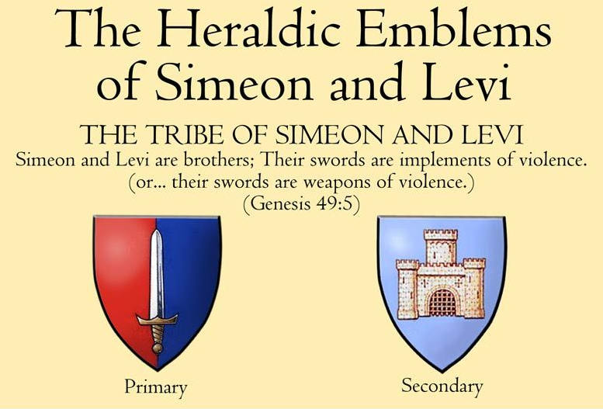
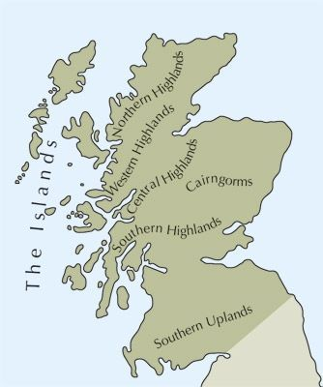
Mountains and hills of Scotland

Wikipedia: “Scotland is the most mountainous country in the United Kingdom. Scotland's mountain ranges can be divided in a roughly north to south direction into: the Scottish Highlands, the Central Belt and the Southern Uplands, the latter two primarily belonging to the Scottish Lowlands. The highlands eponymously contains the country's main mountain ranges, but hills and mountains are to be found south of these as well. The below lists are not exhaustive; there are countless subranges throughout the country.
Ben Nevis (Beinn Nibheis), the highest mountain in Scotland and the United Kingdom at 4,413 feet (1,345 m), is in the Highland region at the western end of the Grampian Mountains. A Scottish mountain over 3,000 feet (910 m) is referred to as a Munro, of which there are 282.
As of 2019, hundreds of thousands of people visit mountains in Scotland every winter and 130,000 climb to the summit of Ben Nevis every year.”

5th Clue: Simeon: towngates / castles

On the third day, when they were sore, two of the sons of Jacob, SIMEON AND LEVI, Dinah’s brothers, took their SWORDS and came upon THE CITY unawares, and killed all the males (Gen 34:25).
SIMEON AND LEVI are brothers; weapons of violence are their SWORDS (Gen 49:5).

Gate of Shechem

Because of the murder of the inhabitants of Shechem, both the sword and the city wall of Shechem became emblems for Simeon and Levi. The city gate often looks like a fortified medieval castle. Levi would also receive other emblems, such as Aaron's rod, and the 12-stone ephod. Therefore, the gate is usually used for Simeon only. Simeon ended up in Scotland and it is therefore remarkable that both Scotland and Wales are full of castles.

Castles in Scotland

Internet: “Scotland has been home to more castles than anywhere else in the UK, with there being around 1,800 castles that have previously, or still do stand today. Although some of these are small remains of what previously stood, there are many impressive and historic castles that still stand in all their original glory.
From the Castle of Mey near John O’Groats, to the iconic Edinburgh Castle, there are many to explore, each with their own unique characteristics. England may claim the oldest inhabited castle in the world and Wales may claim more castles per square mile than any other country, but Scotland has arguably some of the most scenic castles in the world. Plus, Scotland apparently has around 1 castle per every 8,500 people. That is a lot of castles.”
https://www.togethertravel.co.uk/blog/5-scottish-castles-visit-year

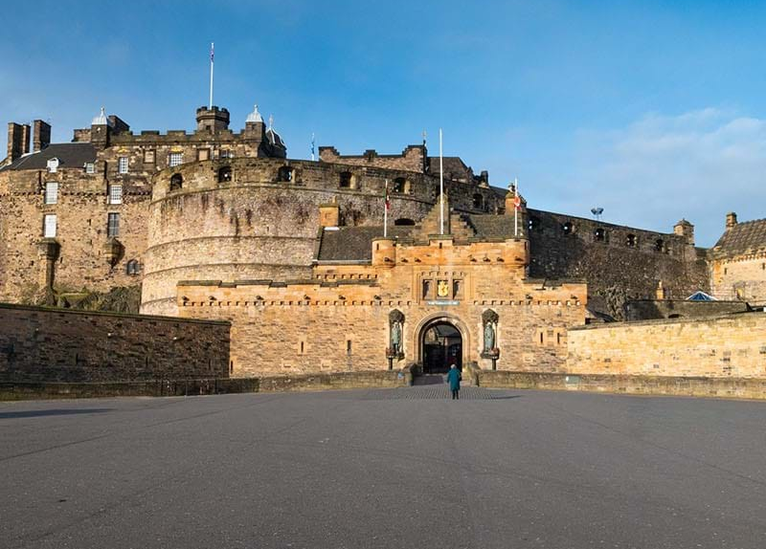
Edinburgh Castle

6th Clue: Simeon & Reuben

The sons of Leah: REUBEN (Jacob's first-born), SIMEON, Levi, Judah, Is'sachar, and Zeb'ulun (Genesis 35:23).
REUBEN, SIMEON, Levi, and Judah (Ex 1:2).
These are the sons of Israel: REUBEN, SIMEON, Levi, Judah, Is'sachar, Zeb'ulun (1Chron 2:1).
Over the tribes of Israel, for the REUBENITES Elie'zer the son of Zichri was chief officer; for the SIMEONITES, Shephati'ah the son of Ma'acah (1Chron 27:16).
And now your two sons, who were born to you in the land of Egypt before I came to you in Egypt, are mine; E'phraim and Manas'seh shall be mine, as REUBEN AND SIMEON are (Genesis 48:5).
On the south side shall be THE STANDARD OF THE CAMP OF REUBEN by their companies, the leader of the people of REUBEN being Eli'zur the son of Shed'eur, his host as numbered being 46,500. AND THOSE TO ENCAMP NEXT TO HIM SHALL BE THE TRIBE OF SIMEON, the leader of the people of SIMEON being Shelu'mi-el the son of Zurishad'dai, his host as numbered being 59,300 (Numbers 2:10-13).

Bond between Reuben & Simeon

Reuben and Simeon had a close bond with each other in the Bible. Reuben and Simeon were the two eldest sons of Jacob, and they were also the two eldest sons of Leah. They were Jacob's only sons until the birth of Levi. Both were passed over in favor of Ephraim and Manasseh (sons of Joseph). Simeon was encamped south of the tabernacle with and under the standard of Reuben.

Scotland & France

Likewise the Scots (Simeon) have a special bond with the French (Reuben).

The Auld alliance

Wikipedia: “TheAuld Alliance (Scots for "Old Alliance") was an alliance between the kingdoms of Scotland and France against England made in 1295. The Scots word auld, meaning old, has become a partly affectionate term for the long-lasting association between the two countries. Although the alliance was never formally revoked, it is considered by some to have ended with the signing of the Treaty of Edinburgh in 1560.
The alliance played a significant role in the relations among Scotland, France and England. The alliance was renewed by all the French and Scottish monarchs of that period except Louis XI. By the late 14th century, the renewal occurred regardless of whether either kingdom was at war with England at the time.
The alliance began with the treaty signed by John Balliol and Philip IV of France in 1295 against Edward I of England. The terms of the treaty stipulated that if either country were attacked by England, the other country would invade English territory. The 1513 Battle of Flodden, where the Scots invaded England in response to the English campaign against France, was one such occasion. Thomas Randolph, Earl of Moray, negotiated the renewal of the alliance in 1326. The alliance played an important role in the Wars of Scottish Independence, the Hundred Years' War, the War of the League of Cambrai, and the Rough Wooing.”

The Garde Écossaise

Since their founding in 1418, the Garde Écossaise, the personal bodyguard to the French monarchy, continued to protect the kings of France until 412 years later, in 1830, when Charles X of France abdicated.
Charles de Gaulle

Wikipedia: “In a speech which he delivered in Edinburgh in June 1942, Charles de Gaulle described the alliance between Scotland and France as "the oldest alliance in the world". He also declared that:
‘In every combat where for five centuries the destiny of France was at stake, there were always men of Scotland to fight side by side with men of France, and what Frenchmen feel is that no people has ever been more generous than yours with its friendship.’
In 1995, celebrations were held in both countries marking the 700th anniversary of the beginning of the alliance.
After extensive research, British historian Siobhan Talbott concluded that the Auld Alliance had never been formally revoked and that it endured and thrived long after the Acts of Union in 1707 and the Entente Cordiale of 1904.”
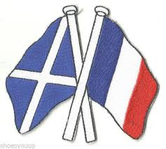

1975

In 1975 I visited Scotland for the first time with three French friends. One evening we were in a pub in Kyle of Lochalsh. My accent had turned Londonish after a year in England, and I ordered a pint. The Scotsman to my right said nothing. My French friend came to my left and we started talking in French. When he went back to the others, the older Scot to my right said: “Ah, you're French. I thought you were English. I don't talk to English people, but the French are our friends.”
(And I am Dutch, ☺ , Bert Otten)

7th Clue: Simeon: envy & hatred

Now Israel loved Joseph more than any other of his children, because he was the son of his old age; and he made HIM A LONG ROBE WITH SLEEVES. 4 But when his brothers saw that their father loved him more than all his brothers, THEY HATED HIM, and could not speak peaceably to him. 5 Now Joseph had a dream, and when he told it to his brothers THEY ONLY HATED HIM THE MORE ... 8 His brothers said to him, "Are you indeed to reign over us? Or are you indeed to have dominion over us?" SO THEY HATED HIM YET MORE FOR HIS DREAMS AND FOR HIS WORDS ... 18 They saw him afar off, and before he came near to them they conspired against him TO KILL HIM ... 23 So when Joseph came to his brothers, they stripped him of his robe, the long robe with sleeves that he wore; 24 and they took him and cast him into a pit. The pit was empty, there was no water in it ... (Genesis 37).
... and [Joseph] returned to them and spoke to them. AND HE TOOK SIMEON FROM THEM AND BOUND HIM BEFORE THEIR EYES (Genesis 42:24b).
Now SIMEON HAD THE COAT, AND WOULD NOT GIVE IT UP, wishing to rend it with his sword; FOR HE WAS ANGRY THAT JOSEPH LIVED, and that he had not slain him (Testament of Zebulun).
And at that time I was JEALOUS of Joseph because our father loved him; and I set my mind against him to destroy him, because the prince of deceit sent forth THE SPIRIT OF JEALOUSY and blinded my mind, that I regarded him not as a brother, and spared not Jacob my father ... And now, children, TAKE HEED OF THE SPIRIT OF DECEIT AND OF ENVY. For ENVY rules over the whole mind of a man, and suffers him neither to eat, nor to drink, nor to do any good thing: it ever suggests to him to destroy HIM THAT HE ENVIES; and he that is envied ever flourishes, but HE THAT ENVIES fades away (Testament of Simeon).

Testament of Envy

The Apocryphal Testaments of the Twelve Patriarchs all have a subtitle. Thus the Testament of Simeon is the testament of jealousy. Of all the 10 brothers, Simeon was the most torn by jealousy, and hated Joseph the most. That is probably the reason why Simeon had to remain as a prisoner in Egypt when the other 9 went back to report to Jacob.

Scottish envy of the English

Internet: “... But to marvel at this mismatch between SNP luxury beliefs and the more parsimonious sensibilities of voters is to ignore the distorting influence of the biggest and baddest outsider of all: the one just over the border. For, although it has become relatively taboo to say so, whatever the official talk of civic rather than ethnic nationalism, a big motivator for SNP supporters in Scotland is still animosity towards the English. [emphasis mine] You can’t raise a population on endless stories about bloody historical injustices at the hands of their ethnic neighbours and then expect them to feel irenic. Certainly, I couldn’t fail to be aware of the enmity during my childhood, where my Southern parentage and wandering accent made me a constant target for cries of “English snob” at school.
Scratch the surface of grassroots SNP support and — not always but frequently — you’ll find slow-burning disdain, perhaps all the stronger for often being suppressed in favour of a more polite narrative. It’s usually confined to living rooms and pubs, but gets permissibly unleashed during football tournaments via support for that other national team, Anyone-But-England. And of course, as Sturgeon knows, an equally traditional means of expressing your feelings in this direction is to say how much you hate the Tories.
In the Scottish cultural imagination, the archetype of the sort of English man or woman that is most hated — Southern, posh-accented, privately-educated, and prone to seeing the country primarily in terms of its potential for invitations to hunting lodges — coincides significantly with the sort of Tory MP the membership still seems to prefer. Everybody knows that in saying you hate the latter, there’s at least the suggestion that you hate the former too. For some extreme nationalist groups, such as All Under One Banner and Siol nan Gaidheal, the equivalence is made without embarrassment.” (Kathleen Stock, internet).

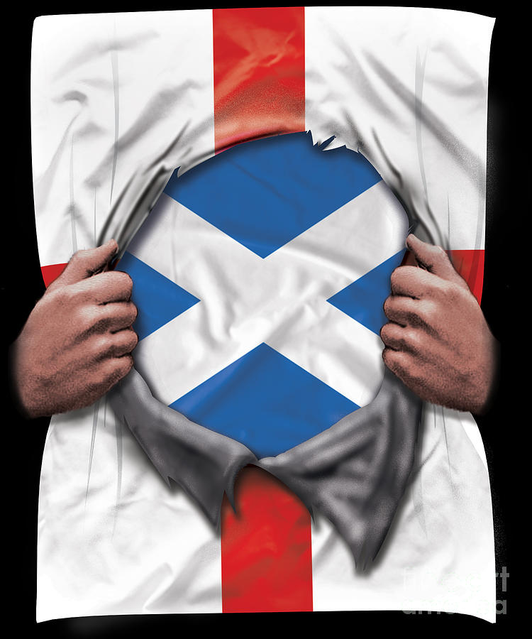

8th Clue: Simeon: preachers

And [Leah] conceived again and bore a son, and said, "Because the LORD has HEARD that I am hated, he has given me this son also"; and she called his name SIMEON [Hebr. SHIM’ON, heard] (Gen 29:33).

Shama, to hear, dictionary:

08085 ע‎משׁ shama’, verb, noun
AV - hear 785, hearken 196, obey 81, publish 17, understand 9, obedient 8, diligently 8, shew 6, sound 3, declare 3, discern 2, noise 2, perceive 2, tell 2, reported 2, misc 33; 1159
Jewish Encyclopedia:

“In Apocryphal and Rabbinical Literature:
Simeon’s name is interpreted as meaning "he who listens to the words of God" (Gen. R. lxxi. 4); or, according to another authority (Midr. ha-Gadol to Gen. xxix. 33), it is composed of
(= "there is sin"), Leah alluding under this name to Zimri, the Simeonite prince who sinned with the Midianite woman (cf. Num. xxv. 6, 14).
Simeon is always represented as having a particularly powerful voice; and it is said that once, in the brunt of a battle, when he shouted, the enemy fled in terror at the sound ("Sefer ha-Yashar," l.c. p. 61a).”

Powerful Preachers

All the things mentioned above are ingredients for powerful preachers:
-being bold
-listening to God's words
-there is sin
-a loud voice ...
Scots are known as powerful preachers.

John Knox (1513-1572)

Christianity Today: “John Knox was a minister of the Christian gospel who advocated violent revolution. He was considered one of the most powerful preachers of his day ... John Knox was indeed a man of many paradoxes, a Hebrew Jeremiah set down on Scottish soil. In a relentless campaign of fiery oratory, he sought to destroy what he felt was idolatry and to purify Scotland's religion.”

Billy Graham (1918-2018)

The Protestants of Northern Ireland are mainly of Scottish descent and are called Scots-Irish. Billy Graham has Scots-Irish roots.

Wikipedia: “William Franklin Graham Jr. ; November 7, 1918 – February 21, 2018) was an American evangelist, an ordained Southern Baptist minister, and a civil rights advocate whose broadcast and live sermons became well known internationally in the mid-to-late 20th century. During a career spanning six decades, Graham was a prominent evangelical Christian figure in the United States. ...
Graham's estimated lifetime audience, including radio and television broadcasts, topped billions of people. As a result of his crusades, Graham preached the gospel to more people in person than anyone in the history of Christianity.”

For other Scottish preachers:
Scottish preachers hall of fame:
http://www.newble.co.uk/hall/hallofame.html
9th Clue: Simeon: subservient

The second lot came out for SIMEON, FOR THE TRIBE OF SIMEON, ACCORDING TO ITS FAMILIES; AND ITS INHERITANCE WAS IN THE MIDST OF THE INHERITANCE OF THE TRIBE OF JUDAH. 2 And it had for its inheritance Beer-sheba, Sheba, Mola'dah, 3 Hazar-shu'al, Balah, Ezem, 4 Elto'lad, Bethul, Hormah, 5 Ziklag, Beth-mar'caboth, Ha'zar-su'sah, 6 Beth-leba'oth, and Sharu'hen -- thirteen cities with their villages; 7 En-rimmon, Ether, and Ashan -- four cities with their villages; 8 together with all the villages round about these cities as far as Ba'alath-beer, Ramah of the Negeb. This was the inheritance of the tribe of Simeon according to its families. 9 THE INHERITANCE OF THE TRIBE OF SIMEON FORMED PART OF THE TERRITORY OF JUDAH; BECAUSE THE PORTION OF THE TRIBE OF JUDAH WAS TOO LARGE FOR THEM, THE TRIBE OF SIMEON OBTAINED AN INHERITANCE IN THE MIDST OF THEIR INHERITANCE (Joshua 9:1-9).

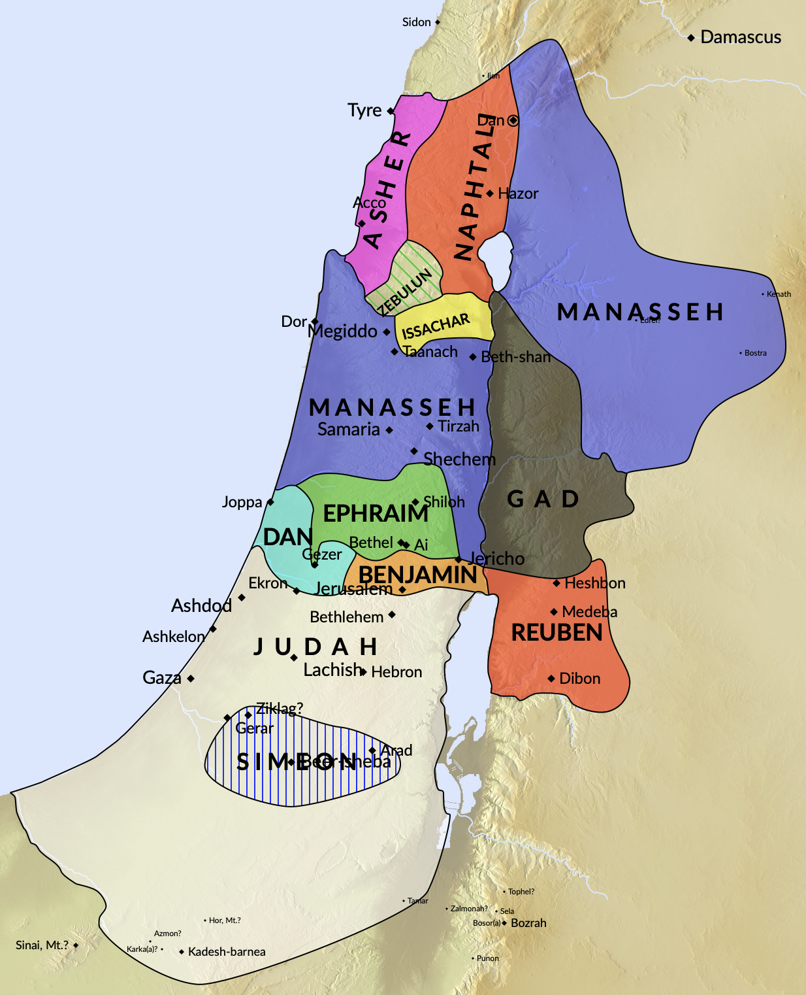

The Simeonites were given an inheritance in the midst of Judah. They started to play a subordinate role. The Simeonites were more or less absorbed into Judah. Since the division of the realm into the Kingdom of Judah and the Kingdom of Israel, we no longer hear from Simeon. Of Benjamin and Judah only.
Before the conquest of the land, the Simeonites had also been greatly reduced in number. At the first count at Sinai there were 59,300 men counted for the army. Forty years later there were only 22,200. Since then the tribe of Simeon played a marginal role.
In the blessing of Moses, in Deuteronomy 33, Moses' blessing for all the tribes, Simeon is not even mentioned at all!
Scots & English

The English were unable to permanently conquer the Scots. Through the personal union of 1603, in which the Scottish king James VI also became king of England (James I), the two countries were united by the royal house. But even then the king moved with his court to the south, because England was much more powerful and more important.
With the Union of 1706, the two countries became one kingdom. The Scottish Parliament moved to London and was merged with the English Parliament. Henceforth, the Scots were ruled far away by the government in Westminster (London). And that's how the Scots still feel today.
The House of Commons is made up of constituency representatives and England has a much larger population than Scotland. So there are many more MPs from England (543) than from Scotland (57). This leads to a subordinate role for the Scots in the kingdom. This was clearly reflected in Brexit. A majority of English people were in favor of Brexit, a majority of Scots were against Brexit.
Scots (Simeon) play a subordinate role compared to the English (Joseph, Ephraim). Consider the fact that Joseph had Simeon bound:
Then he turned away from them and wept.
Then [Joseph] returned to them and spoke with them; he took Simeon from among them and bound him in their presence (Gen 42:24).
Simeon (Scotland) is still tied to Joseph (England).

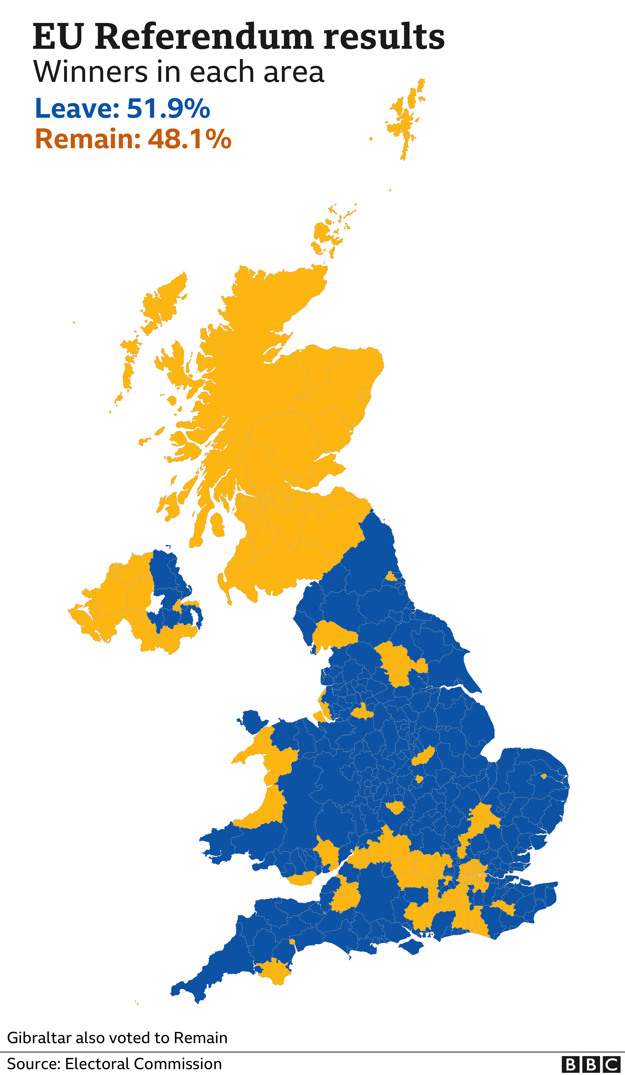

The English dragged the Scots out of the EU against their will.
10th Clue: Simeon: coat of many colours

Now Israel loved Joseph more than all his children, because he was the son of his old age: and he made him A COAT OF MANY COLOURS ... And it came to pass, when Joseph was come unto his brethren, that they stript Joseph out of his coat, HIS COAT OF MANY COLOURS that was on him ... And they sent THE COAT OF MANY COLOURS, and they brought it to their father; and said, This have we found: know now whether it be thy son’s coat or no (Gen 37:3, 23, 32, KJV).
Now SIMEON HAD THE COAT, AND WOULD NOT GIVE IT UP, wishing to rend it with his sword; for he was angry that Joseph lived, and that he had not slain him (Testament of Zebulun).

Multicolored Robe – Tartan & Kilt

In light of the first nine clues, we can include the tartan and the kilt as the tenth clue. Joseph was given a coat of many colours and Simeon was jealous. The multi-colored tartan represents Simeon's jealousy of Joseph.

Tartan, Wikipedia:

“The Timeless Elegance of Tartan:
A Closer Look at Scotland's Iconic Pattern
Tartan, a quintessential symbol of Scottish heritage, weaves a tale as intricate as the patterns adorning its fabric. This article aims to explore the rich history and cultural significance of tartan, shedding light on its evolution from a regional textile to a global emblem of identity.

Origins and Evolution
Tartan, known in Scottish Gaelic as "breacan," is characterized by its intersecting horizontal and vertical bands, creating mesmerizing patterns in an array of colors. Initially woven from wool, tartan has now transcended its traditional material boundaries, finding expression in various fabrics.
Historically, tartan was closely intertwined with Scottish identity, particularly associated with the Highlands. Its origins trace back to local weavers crafting patterns based on available natural dyes, with designs reflecting regional tastes rather than clan affiliations. However, the Dress Act of 1746 sought to suppress Highland culture by banning tartan attire, only to be repealed in 1782. This legislative shift paved the way for tartan's resurgence, culminating in its endorsement as Scotland's national dress during King George IV's visit in 1822.

Clan Tartans and Commercialization
While tartan's association with specific clans gained prominence in the early 19th century, it wasn't until the Victorian era that tartan witnessed a surge in popularity. The advent of synthetic dyes facilitated mass production, enabling the creation of myriad tartan patterns at affordable prices. This commercialization coincided with a romanticized view of Scottish history, perpetuating the allure of tartan as a symbol of heritage and prestige ...

Etymology and Terminology
The term "tartan" likely derives from the French word "tiretaine," signifying linen-wool cloth, or Scottish Gaelic words like "tarsainn" or "tarsuinn," meaning "across" or "crossing over." Over time, "tartan" came to represent both the pattern and the weave, evolving from its Gaelic counterpart, "breacan," meaning "many colors."
The distinctive pattern of tartan, known as its "sett," comprises intersecting lines of specific widths, blending harmoniously to create visually captivating designs. Today, "tartan" encompasses a broad spectrum of applications, transcending its textile origins to permeate various facets of contemporary culture.
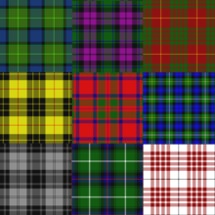
Tartans come in a wide variety of colours and patterns

In Conclusion
Tartan stands as a timeless emblem of Scottish heritage, weaving together threads of tradition, identity, and craftsmanship. From its humble origins in local weavers' cottages to its global resonance in contemporary culture, tartan continues to captivate hearts and minds, transcending borders and generations. As we celebrate its legacy, let us honor tartan's enduring spirit, a testament to the power of tradition and creativity woven into the fabric of human history.
The tartan kilt, a quintessential symbol of Scottish culture and tradition, embodies elegance and heritage like no other garment. Crafted from meticulously woven tartan fabric, each kilt tells a story of lineage and pride, honoring centuries of craftsmanship. For those eager to embrace this timeless attire, a tartan kilt shop beckons, offering a myriad of designs to suit every taste and occasion. Step into the world of tartan, where history meets modernity, and find your perfect kilt today.”
Bert Otten, May 2024
Gouda, Holland

For my other articles about the other tribes:
https://sites.google.com/site/waarheidvrede/the-ten-lost-tribes

